Step 1 — Preparing the Server

Before we can install CouchDB, we need to ensure that the server is set up for it.

Begin by updating the system:

* sudo apt-get update

Install the software that allows you to manage the source repositories:

* sudo apt-get install software-properties-common -y

**Note:** The -y flag tells the apt-get command to assume a Yes response to all the prompts that might come up during the installation process. You can drop this flag if you prefer responding manually to the prompts.

Add the PPA that will help us fetch the latest CouchDB version from the appropriate repository:

* sudo add-apt-repository ppa:couchdb/stable -y

**Warning:** Great care should be taken while adding a new Personal Package Archive (PPA) to your server. Since anyone can create a PPA, there's no guarantee that it can be trusted or that it is secure. In this case, the above PPA is an official one, maintained by the Apache CouchDB team.

Now that we have added a new PPA, let's update the system so that it has the latest package information:

* sudo apt-get update

We are now ready to install CouchDB and Futon.

Step 2 — Installing CouchDB

If you previously had CouchDB installed on this server, begin by removing the existing version:

* sudo apt-get remove couchdb couchdb-bin couchdb-common -yf

**Note:** If you have a fresh Droplet, you can ignore this step.

Now install CouchDB:

* sudo apt-get install couchdb -y

This will install CouchDB and Futon on your server.

By default, CouchDB runs on **localhost** and uses the port **5984**. You can retrieve this basic information by running curl from the command line:

* curl localhost:5984

**Note:** If you don't have curl installed, you can use the sudo apt-get install curl command to install it.

You should get something similar to the following:

Output

{"couchdb":"Welcome","uuid":"b9f278c743b5fc0b971c4e587d77582e","version":"1.6.1","vendor":{"name":"Ubuntu","version":"14.04"}}

You can now create a new database with the curl -X PUT command:

* curl -X PUT localhost:5984/new_database

The results should look like this:

Output

{"ok":true}

Step 3 — Securing the CouchDB Installation

By default, some of the files and directories created when CouchDB is installed belong to the **root** user and group. While this is fine (albeit not advisable) during development, it could be a security risk in production.

When CouchDB is installed, it creates a user and a group named **couchdb**. In this section we will change the ownership and permission of the CouchDB files to the **couchdb** user and group.

Changing the ownership controls *what* the CouchDB process can access, and changing the permissions controls *who* can access the CouchDB files and directories.

Before changing the ownership and permissions, stop CouchDB:

* sudo stop couchdb

Change the ownership of the /usr/lib/couchdb, /usr/share/couchdb, and /etc/couchdb directories, and the /usr/bin/couchdb executable file, such that their owner is **couchdb** and they belong to the **couchdb** group.

* sudo chown -R couchdb:couchdb /usr/lib/couchdb /usr/share/couchdb /etc/couchdb /usr/bin/couchdb

Now, change the permissions of the /usr/lib/couchdb, /usr/share/couchdb, and /etc/couchdbdirectories, and the /usr/bin/couchdb executable file, such that the **couchdb** user and the **couchdb** group have complete access (to the CouchDB installation) while no other user has access to these files and directories.

* sudo chmod -R 0770 /usr/lib/couchdb /usr/share/couchdb /etc/couchdb /usr/bin/couchdb

All that's left to do is restart CouchDB:

* sudo start couchdb

CouchDB should now be up and running without any of its files or directories belonging to either the **root** user or the **root** group.

Step 4 — Accessing Futon

CouchDB offers a convenient web-based control panel called Futon. We're going to access it from your **local workstation**, tunneling the traffic through an SSH connection to your server. This means that only users with an SSH login to your server can access the Futon control panel.

To connect securely to CouchDB, without making it publicly available, you can create an SSH tunnel from your local port 5984 to the remote server's port 5984.

You can use the following command, run from your **local computer**, to set up the tunnel:

* ssh -L5984:127.0.0.1:5984 sammy@your_server_ip

**Note:** Remember to replace sammy with your username and your_server_ip with the IP address of your Droplet.

While the connection is open, you can access Futon from your favorite web browser, using port 5984. Visit this URL to display the helpful Futon page:

http://localhost:5984/_utils

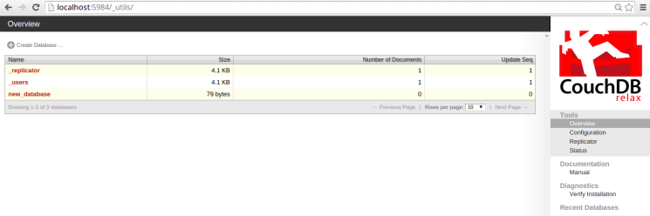

By default, all CouchDB users who access Futon do so with administrative rights. This is announced in the bottom right corner:

Welcome to Admin Party! Everyone is admin. Fix this

You can change this by clicking on the little **Fix this** link and creating new administrators.

Step 5 — Adding an Admin User

Now that we have CouchDB up and running, let's start using it.

Before an admin user is created, all users can access CouchDB with administrative privileges (although they require SSH access to the server first).

It's a good practice to create an admin account for CouchDB, to prevent accidental or unauthorized data loss.

To do this, click the **Fix this** link that appears in the bottom right corner of Futon. This will bring up a screen that allows you to create a CouchDB admin user, as follows:

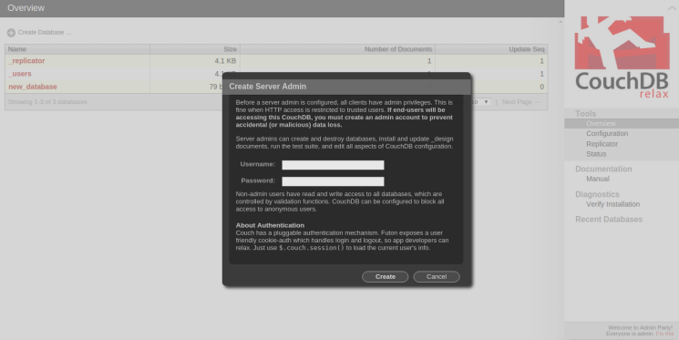

Enter the desired username and password:

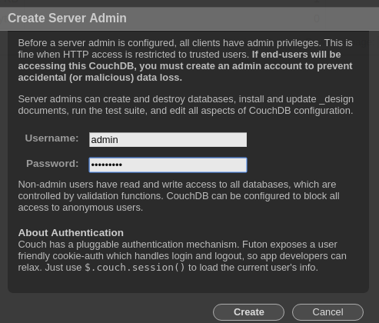

After entering your new CouchDB username and a secure password, click the **Create** button. This will create the new admin user. The message in the bottom right corner of Futon will confirm this by showing a message similar to the following:

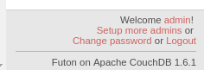

**Note:** The creation of an admin user prevents unauthorized users from deleting and modifying databases, design documents, and the CouchDB configuration. However, it doesn't prevent them from creating or accessing documents.

Be careful about handing out SSH access to your server.

That's it! Our CouchDB server is now fully configured.

To learn more about using the database, keep reading.

Performing CRUD Operations from Futon

Futon has a very simple but useful user interface which allows you to perform basic CRUD operations (create, read, update, and delete).

In this section, we will create a new database named todos, add a new document to it, and then retrieve, update, and delete this document.

**Note:** If you have created an admin user, you will have to be logged in as the administrator to create a new database.

Make sure you still have your SSH tunnel open. If not, open your connection to the server from your **local computer** with this command:

* ssh -L5984:127.0.0.1:5984 sammy@your_server_ip

Let's begin by visiting the Futon page at http://localhost:5984/_utils/.

**Note:** This section assumes that CouchDB is being accessed using an SSH tunnel that was set up as described in in the **Accessing Futon** section above. If your setup is different, make sure you access Futon at the correct URL.

**Create a Database and Document**

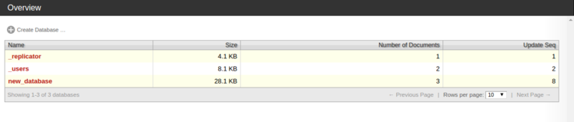

To create a new database called todos, click the **Create Database** link on the screen. This will bring up a dialog as follows:

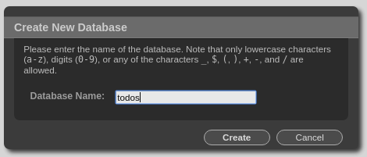

Enter the name of the database and click the **Create** button.

This will create a new database named todos and take you to a page where you can start creating and modifying documents in the newly created database.

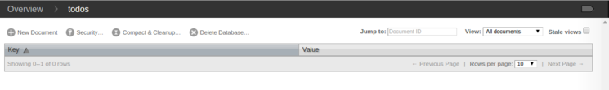

**Create Document**

To create a new document, click the **New Document** link on the page.

This will open up a screen with a new document. This document will have just the _id field. You can change the value of this field if you need to or you can leave it as is.

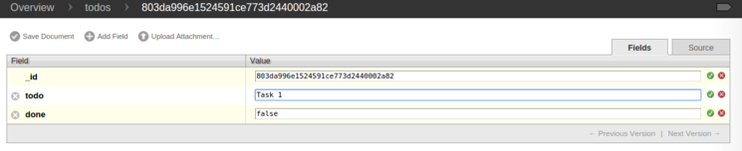

Click the **Add Field** link to add a new field to this document.

As can be seen above, we have added two fields named todo and done. By default, new fields have a null value.

Double-click the value to change it.

In this example, we have double-clicked the value fields of todo and done and have entered the values Task 1 and false respectively.

Once you have entered the values, either press the ENTER key or click the little green check mark next the field to save its contents. (Failing to do this will leave the value of the field as null.) This should look as follows:

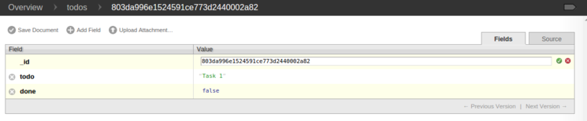

To save the document, click the **Save Document** link. After the document is saved, you will see that a _rev field has been added to it as follows:

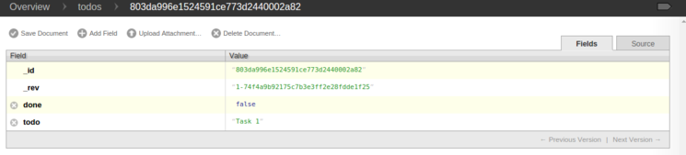

**Read a Document**

Click on the todos link (in the top bar next to the Overview link) to view the newly-created document, as the only document in the todos database.

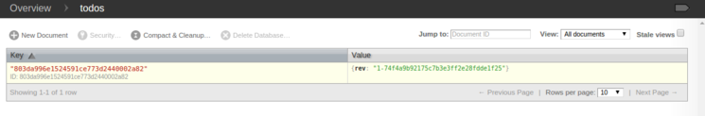

Click on the key of the document (the ID) in the table to access the document details page.

**Edit a Document**

On this page, you can edit and update the document fields as follows:

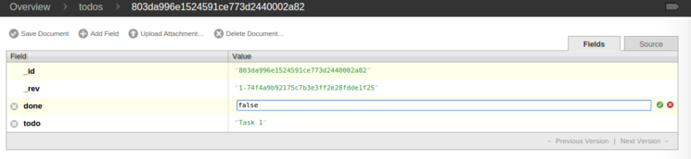

To edit a field value, double-click it and start editing.

You can delete any field (apart from the _id and _rev fields), add new fields, or change the values of existing fields. In this example, we have changed the value of the done field from false to true as follows:

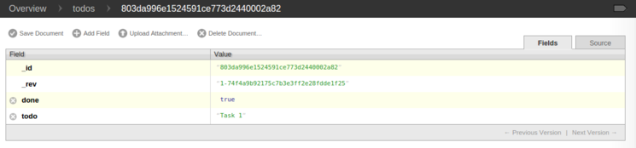

After you are satisfied with the changes, click the **Save Document** link to update the document. Once you do so, you'll notice that the value of the _rev field has been updated as well.

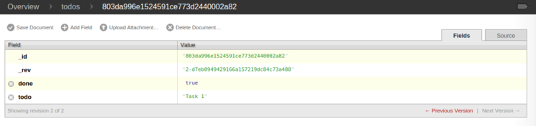

**Delete a Document**

To delete a document, you can click the **Delete Document** link which will prompt you for confirmation:

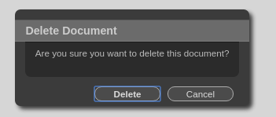

Confirm by pressing the **Delete** button.

Futon will delete the document and take you to the todos database page, which should now be empty, confirming that the document has indeed been deleted.



Performing CRUD Operations from the Command Line

This section will illustrate how we can perform basic CRUD (create, read, update, and delete) operations on a CouchDB database from the command line using curl.

Make sure you still have your SSH tunnel open. If not, open your connection to the server from your **local computer** with this command:

* ssh -L5984:127.0.0.1:5984 sammy@your_server_ip

**Note:** This section will use the database new_database that was created in Step 2 (**Installing CouchDB**) above. This section will also assume that we are accessing CouchDB using an SSH tunnel as described in the **Accessing Futon** step above. If your setup is different, make sure you replace the URL, PORT, and the database names appropriately while executing the commands used below.

**Create a Database**

If you didn't already create the database new_database, please do so now. This command should be executed from your **local workstation**:

* curl -X PUT http://localhost:5984/new_database -u "admin:password"
* {"ok":true}

Since we added an admin user to CouchDB, we now have to send the admin username and password when creating a new database.

The results should look like this:

Output

{"ok":true}

**Create a Document**

Let's begin by creating a new document.

* curl -X POST -d '{"todo":"task 1", "done":false}' http://localhost:5984/new_database -H "Content-Type:application/json"

This command creates a new document in the new_database database.

The -X flag indicates that we are performing an HTTP POST operation. The -H flag followed by the header sets the content type of this request as application/json since we are POSTing a JSON document. Finally, the JSON document itself is included, along with the -d flag.

The response of this operation is as follows:

Output

{"ok":true,"id":"803da996e1524591ce773d24400004ff","rev":"1-2fc1d70532433c39c9f61480607e3681"}

The "ok":true part of this response indicates that the operation was successful. The response includes the fields id and rev, which represent the document ID and the document revision respectively. Both these fields will be required in case this document needs to be modified or deleted.

In this example, the document ID was generated by CouchDB because we didn't supply it with the command. If required, we can create a document with a unique ID that we have generated.

**Create with Specified ID**

Create a document with the ID random_task:

* curl -X POST -d '{"_id":"random_task", "todo":"task 2", "done":false}' http://localhost:5984/new_database -H "Content-Type:application/json"

This command creates a new document with the ID set to random_task. The response to this command is as follows:

Output

{"ok":true,"id":"random_task","rev":"1-bceeae3c4a9154c87db1649473316e44"}

**Create Multiple Documents**

In addition to creating single documents, we can also create documents in bulk.

* curl -X POST -d '{"docs": [{"todo":"task 3", "done":false}, {"todo":"task 4", "done":false}]}' http://localhost:5984/new_database/_bulk_docs -H "Content-Type:application/json"

This command will create two documents as specified in the POST body. There are two slight differences, as compared to the single-document inserts:

1. While inserting a single document, the POST body was just a standard JSON object. In case of bulk inserts, the POST body comprises an object with a docs field. This field holds the array of documents that are to be inserted.
2. While inserting a single document, the POST request was sent to the URL pointing to the database (http://localhost:5984/new_database). The request for bulk inserts, however, POSTs to the http://localhost:5984/new_database/_bulk_docs URL.

The response of the bulk insert operation is as follows:

Output

[{"ok":true,"id":"803da996e1524591ce773d24400007df","rev":"1-778fd61f8f460d0c1df1bb174279489d"},{"ok":true,"id":"803da996e1524591ce773d2440001723","rev":"1-dc9e84861bba58e5cfefeed8f5133636"}]

**Read a Document**

Retrieving a document from a CouchDB database is a simple matter of issuing an HTTP GET command. Let's try to retrieve one of the documents we created above: the one called random_task.

* curl -X GET http://localhost:5984/new_database/random_task

Note that the URL includes the ID (random_task) of the document which is being retrieved. The response to this GET request, as shown below, contains the entire document along with the _id and the _revfields, which can be used to update or delete this document.

Output

{"_id":"random_task","_rev":"1-bceeae3c4a9154c87db1649473316e44","todo":"task 2","done":false}

**Edit a Document**

While trying to update a document, it is important to include the _rev field. CouchDB will reject any update request which doesn't include a _rev field. Since CouchDB updates the entire document, and not just parts of it, the entire document must be sent in the request body during an update operation.

To update the document that was created with the ID random_task, we need to issue an HTTP PUT request as follows:

* curl -X PUT -d '{"_rev":"1-bceeae3c4a9154c87db1649473316e44", "todo":"task 2", "done":true}' http://localhost:5984/new_database/random_task

Be sure to replace the _rev value with the string you received in the previous output.

This modifies the document and updates the done field to true. The response to this request is as follows:

Output

{"ok":true,"id":"random_task","rev":"2-4cc3dfb6e76befd665faf124b36b7f1c"}

As can be seen in the response, the rev field for this particular document changes after it has been updated. Any future request to update or delete this document will now have to use the newest revvalue.

**Delete a Document**

Let's use this new rev value to delete this document using an HTTP DELETE request as follows:

* curl -X DELETE http://localhost:5984/new_database/random_task?rev=2-4cc3dfb6e76befd665faf124b36b7f1c

Just like the GET & PUT requests above, the DELETE request uses the URL that points to the document. However, it also includes an additional query parameter in the URL. This parameter, rev, should have the latest _rev value for the delete operation to be successful.

In this particular case, we use the value that was returned after the update operation in the previous step. The response to the above request is shown below.

Output

{"ok":true,"id":"random_task","rev":"3-07d6cde68be2a559497ec263045edc9d"}

Restarting, Stopping, and Starting the CouchDB Service

Starting, stopping and restarting the CouchDB service is quite straightforward. Complete these steps from the **server**.

**Restart**

To restart a running CouchDB instance, execute the following command:

* sudo restart couchdb

This command will restart a running CouchDB instance and display the process ID of the new instance. In case there is no instance of CouchDB running, executing this command will give a message like

Output

restart: Unknown instance:

**Stop**

To stop a running CouchDB instance, execute the following command:

* sudo stop couchdb

Executing this command will stop any running CouchDB instance and provide a confirmation message like this:

Output

couchdb stop/waiting

**Start**

To start CouchDB, execute the following command:

* sudo start couchdb

If CouchDB wasn't already running, executing this command will start CouchDB and provide a confirmation message like this:

Output

couchdb start/running, process 12345

On the other hand, if there was a CouchDB instance already running then executing the above command will result in a message like this:

Output

start: Job is already running: couchdb

**Status**

In case you want to check the status of CouchDB, you can do so using the following command:

* sudo status couchdb

If CouchDB is running, this will give a message similar to the following:

Output

couchdb start/running, process 12345

If CouchDB is not running, checking the status will result in something like:

Output

couchdb stop/waiting

Conclusion

You now have a fully functional setup of CouchDB on your Droplet, which you can securely administer from your local machine using Futon or the command line.